Database Tutorial 1:

Liam Noone

G00420041:

1. Return all actors whose last names are ALLEN from the actor table.

Actors:

Cuba Allen

Kim Allen

Meryl Allen

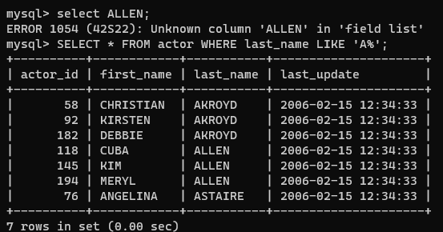

1. Return all the actors whose last name column has a value DAVIS, and the row’s first name has a value SUSAN.

There is 2 Susan Davises.

1. Return all actors where last name column has a value ALLEN or DAVIS.

1. Return the number of categories which have a name that does not start with the letter A.

14 Categories.

1. Return all actor names and the name of each film title they were in.

1. Return the title, release year, and category of all movies.

1. Return how much JOHNNY TURPIN has spent on movie rentals.

1. Return the name of the customer that has spent the most of movie rentals, include the amount they have spent.

1. Return all movie title, release year, actor name and category where the actor first name is ‘Sean’A computer screen with white text

   Description automatically generated
2. Explore the database and create ten more challenging SQL statement, something different to the above. (Just Select, no create, update or delete statements
3. Actors who have appeared in over 100 movies.

1. **List the names of actors who have appeared in movies released in the last 3 years:**
2. Most rented movies

1. customers who have rented more than once.

1. list total customers

1. total movies in inventory

1. Total staff members.

1. Movies not in English

